Ergoneers Dikablis Eye Tracker Headset

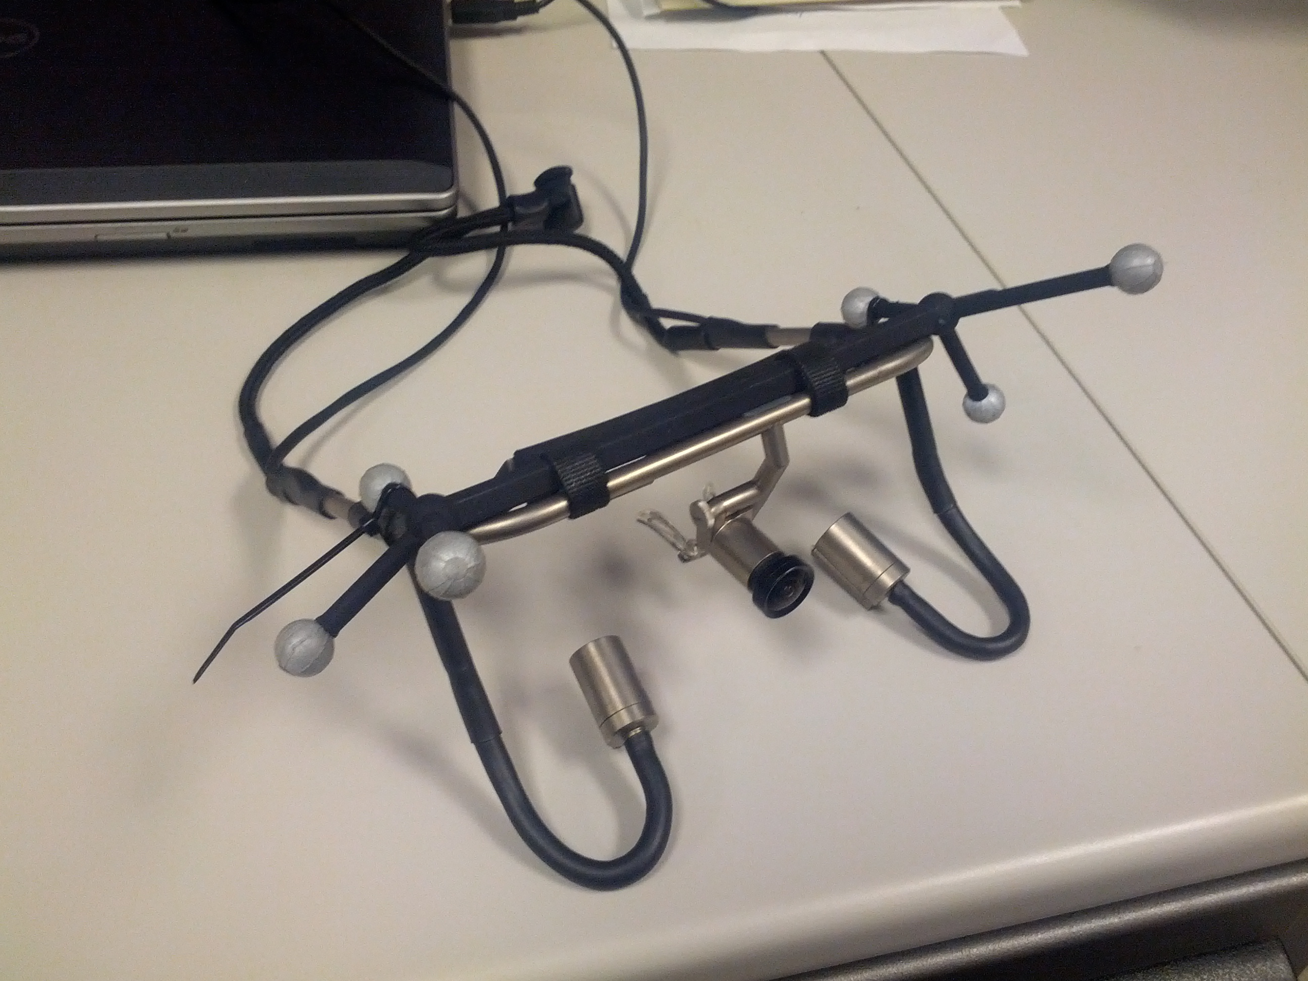
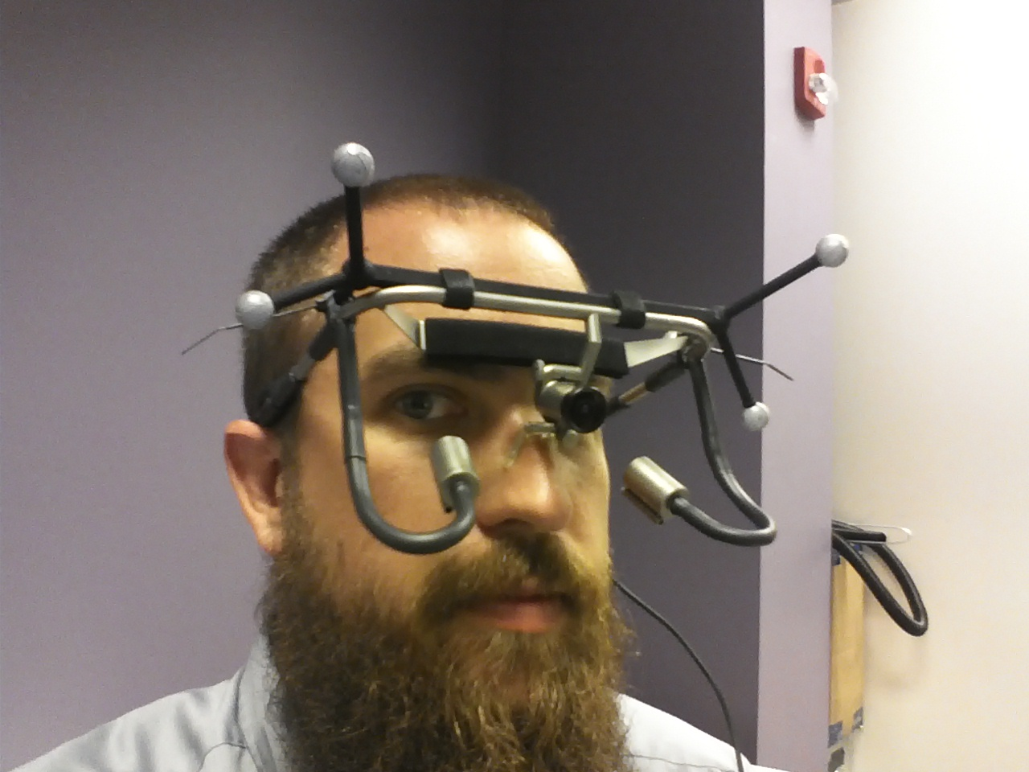
The Dikablis eye tracker is a head-mounted eye tracker from Ergoneers GmbH. The tracker uses one camera for each eye, mounted on flexible arms to position comfortably below the wearer’s eye. A forward-facing camera mounted between the eyes captures the scene from the user’s perspective. An adjustable nosepiece and an adjustable strap provide security and comfort. Users are free to move their head around, but are limited in bodily movements due to cables connecting the headset to a pair of laptops. The laptops run proprietary software that records pupil movements from each camera, along with video from the forward facing camera.

In order to record accurate data, the device must first be calibrated to the wearer. The procedure involves 3 simple steps. First, the camera positions are adjusted to center on the pupil. Second, the sensitivity of the cameras are adjusted to be capture pupil position. Last, the wearer focuses on 4 fixed calibration points on a wall in front of them. Each of these points is marked in the software to complete the calibration procedure.

The Dikablis eye tracker can track where the user is looking, with a degree of accuracy of half a degree. The Dikablis tracks the gaze of both eyes, can tell when the user blinks or winks, and what eye was winked with.

Info taken from http://www.ergoneers.com.

