**The SR Research Eyelink Eye Tracker**

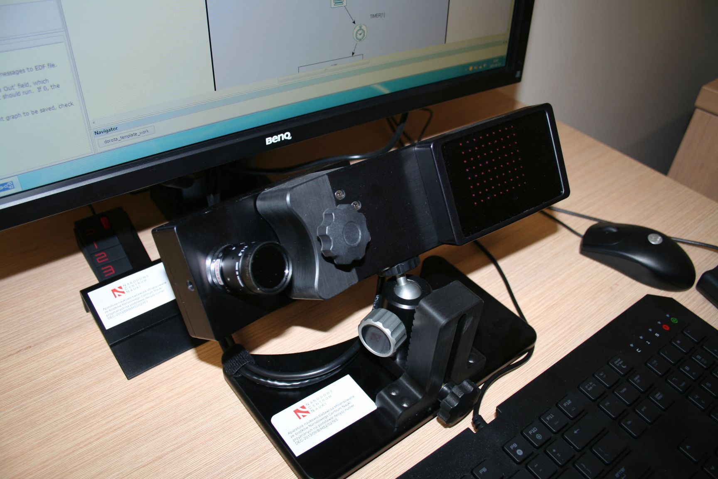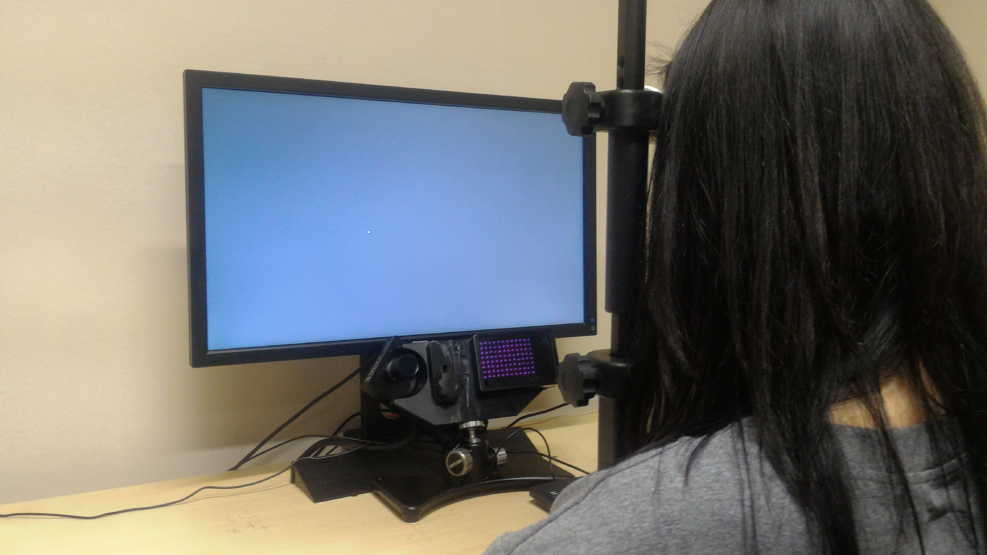 The SR Research Eyelink eye tracker is a standalone eye tracking device to be used with computer displays. The eye tracker is positioned or mounted at the bottom of a display unit. Using the Eyelink is very similar to using a regular computer monitor except that the chin must be placed in a chest to restrict head movements. Otherwise, the eye tracking process is unobtrusive. There are no protrusions, bright lights, noises or other obvious distractions for the user. The Eyelink is very easy to use, and can be used by people with very little computer experience. In order to use the Eyelink, the user sits in front of it, as he or she would a computer monitor. The user then begins one of many applications made for use with the Eyelink. The first step in all of these programs is to calibrate the device, a process involving watching a dot move from between two to nine places on the screen. This is done to bolster the accuracy of the eye tracking data. When the user is finished using the Eyelink, no special steps are needed. The user simply gets up and walks away from the device. If a new user wishes to use the Eyelink, the calibration step must be re-done, but it requires no additional steps of shutdowns. With the exception of the calibration step, using the Eyelink is exactly like using a regular computer.

The Eyelink can track where the user is looking on the screen, with a degree of accuracy of half a degree, about 50 pixels. The Eyelnk tracks the gaze of both eyes, and the distance of the eyes from the screen. It can tell when the user blinks, or winks, and what eye was winked with, all without distracting the user.