The Gazepoint GP3 Eye Tracker

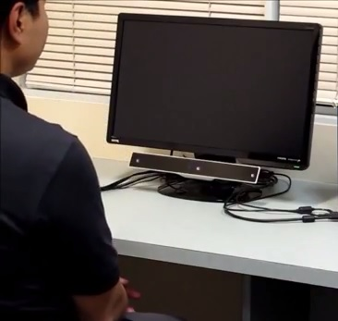
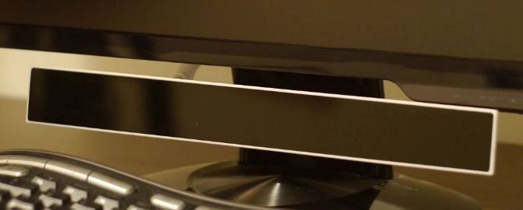
The Gazepoint GP3 eye tracker is a standalone eye tracking device to be used with computer displays and laptops. The eye tracker is positioned or mounted at the top or bottom of a display unit. Using the Gazepoint GP3 is very similar to using a regular computer monitor. Users are free to move their head, and are not restrained in any way. The eye tracking process is unobtrusive. There are no protrusions, headgear, bright lights, noises or other obvious distractions for the user. The Gazepoint is very easy to use, and can be used by people with very little computer experience. In order to use the Gazepoint, the user sits in front of it, as he or she would a computer monitor. The user then begins one of many applications made for use with the Gazepoint. The first step in all of these programs is to calibrate the device, a process involving watching a dot move from between two to nine places on the screen. This is done to bolster the accuracy of the eye tracking data. When the user is finished using the Gazepoint, no special steps are needed. The user simply gets up and walks away from the device. If a new user wishes to use the Gazepoint, the calibration step must be re-done, but it requires no additional steps of shutdowns. With the exception of the calibration step, using the Gazepoint is exactly like using a regular computer.
The Gazepoint can track where the user is looking on the screen, with a degree of accuracy of half a degree, about 50 pixels. The Gazepoint tracks the gaze of both eyes, and the distance of the eyes from the screen. It can tell when the user blinks, or winks, and what eye was winked with, all without distracting the user.

Pictures and info taken from www.gazept.com

